**Part B Tests - Group 4**

When run this Thread Monitor window appears showing initial Thread information. This includes the Thread name, ID, State, Priority and Daemon. The threads displayed are Reference Handler, Finalizer, Signal Dispatcher, main, Monitor Ctrl-Break and Common-Cleaner.

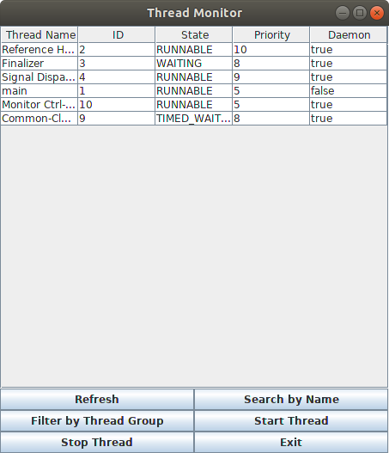

**Refresh Button Test**

Once the refresh button is clicked, the following is displayed.

The threads Java2D Disposter, AWT- XAWT, AWT-Shutdown, TimerQueue, AWT-EventQueue-0, DestroyJavaVM are added and the thread main is removed.

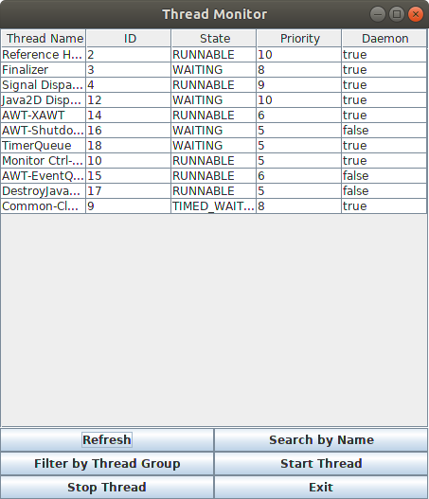

**Search by Name Button Test**

* The following window pops up once this button is clicked.
* Thread Name:Finalizer is entered into the window.

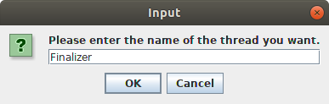

* Output of the thread name entered from above

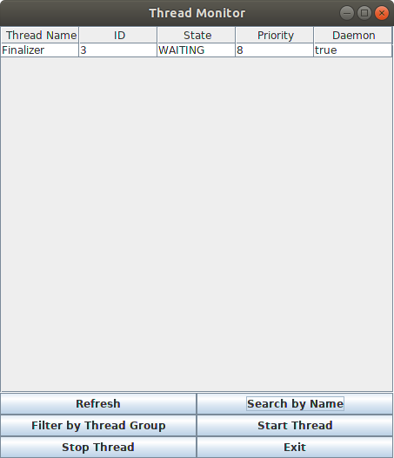

**Search by Name Button Test 2 - Input Check**

* Unexpected input entered : an error message is displayed

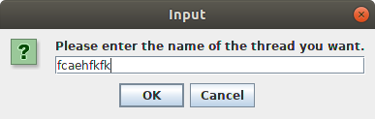

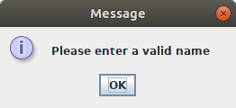

**Filter by Thread Group Button Test**

* The following window pops up once this button is clicked.
* Thread Group:main

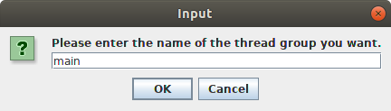

* Outputs the threads in the thread group main

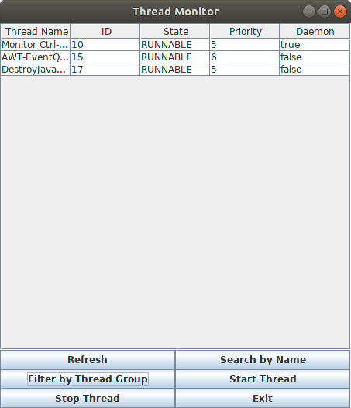

**Filter by Thread Group Test 2 - Input check**

* Unexpected input entered : an error message is displayed

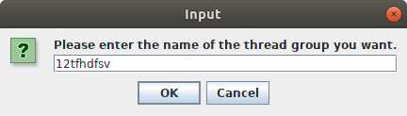



**Start Thread Button Test**

-Thread Name:Finalizer is entered into the window.

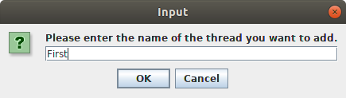

* A warning message is displayed before the adding of the new thread

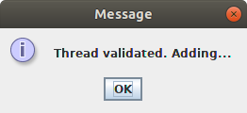

* A new thread called First is added

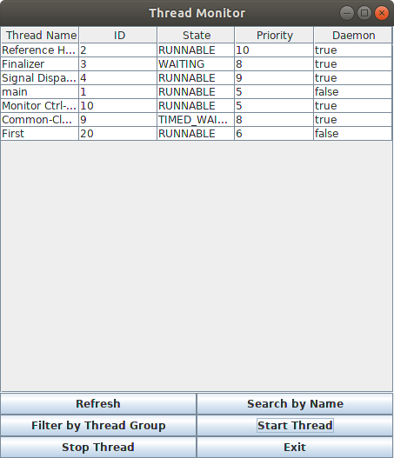

**Stop Thread Button Test**

-Thread Name:Finalizer is entered into the window.

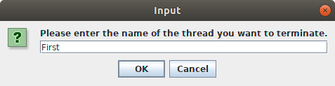

* A warning message is displayed before the thread is terminated

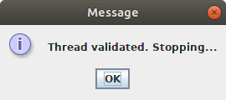

* Output of the thread group entered from above

The Thread First is terminated.

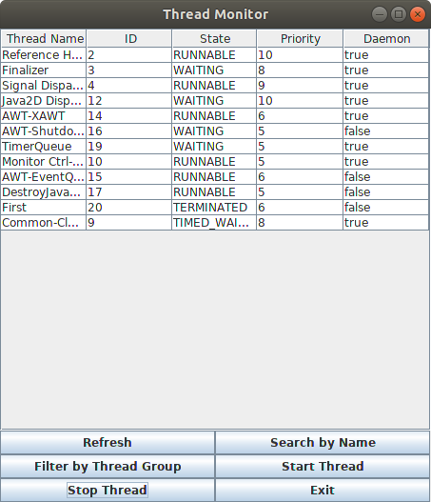

**Stop Thread Button Test 2 - Input Check**

* Unexpected input entered : an error message is displayed

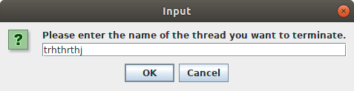



**Exit - Closes the program**